ASSIGNMENT 4

K.VIKAS

2403A52126

TASK 1

Zero-shot: Prompt AI to write a function that checks whether a given year is a leap.

Code and output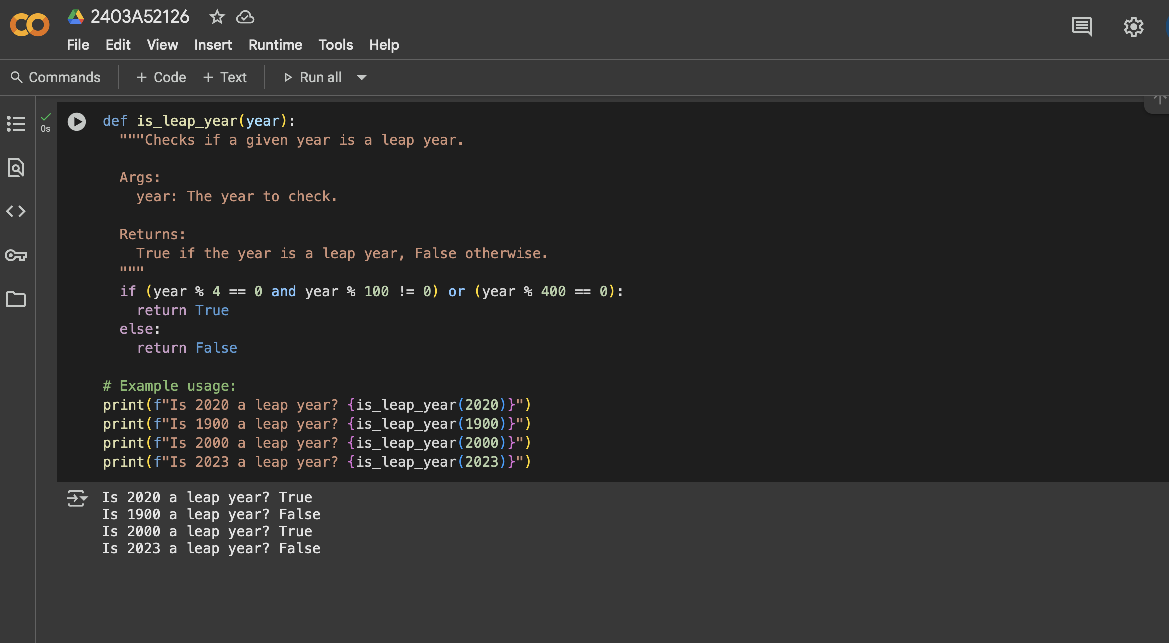

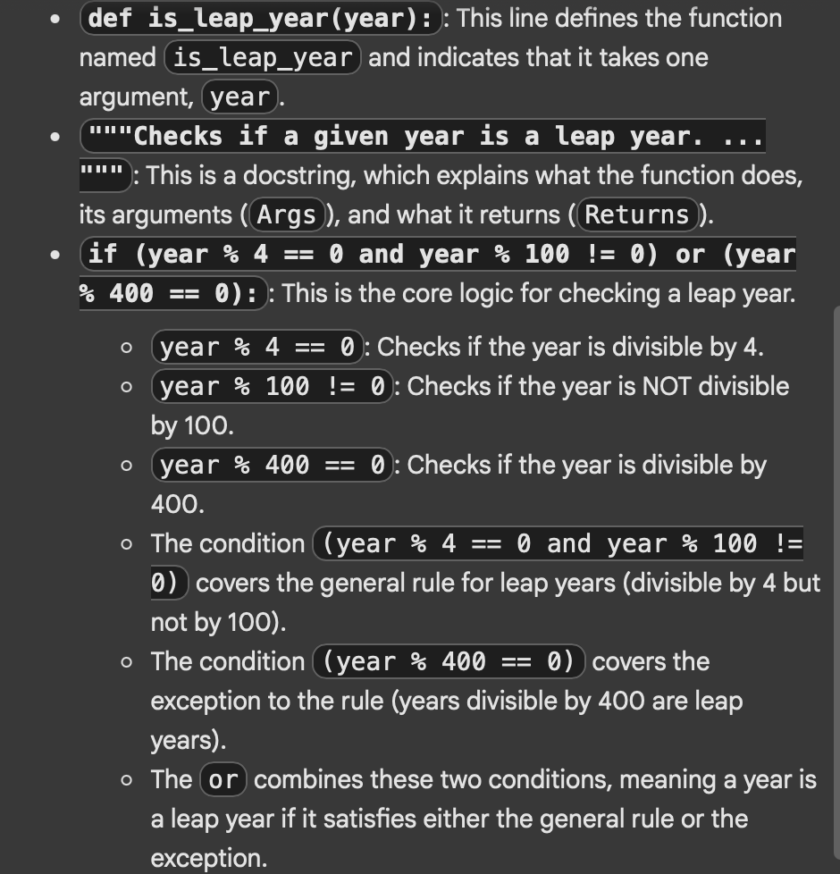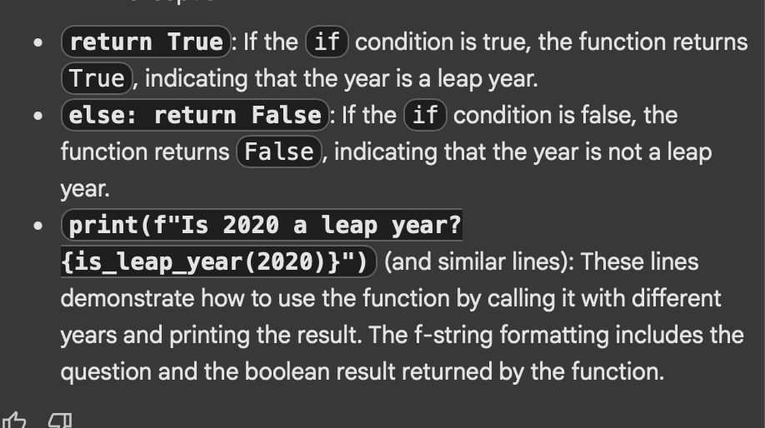

Explanation of code

TASK 2

One-shot: Give one input-output example to guide AI in writing a function that

converts centimeters to inches.

Prompt given for one shot code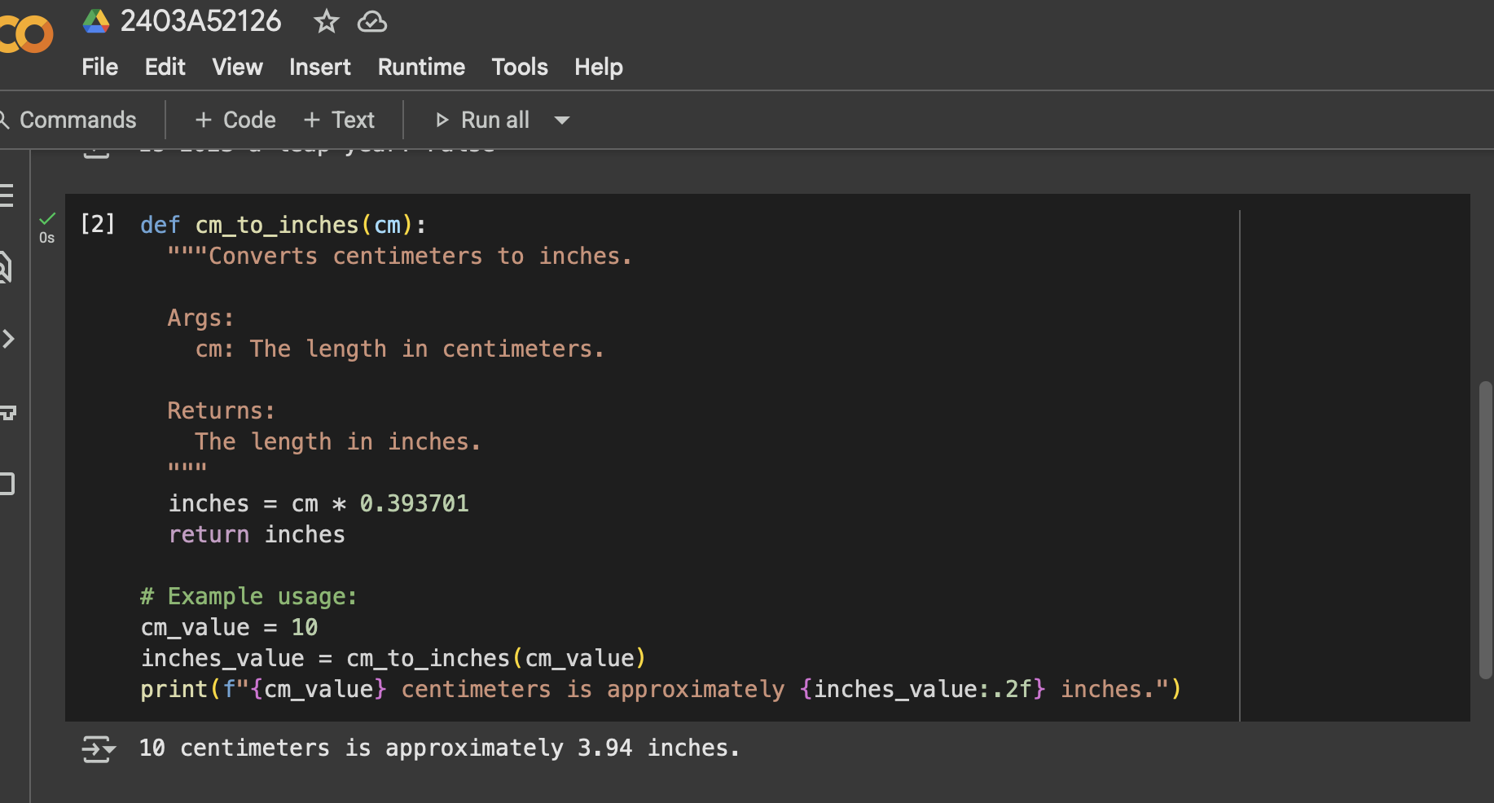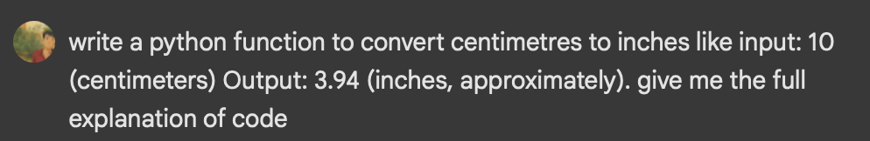

Code and output

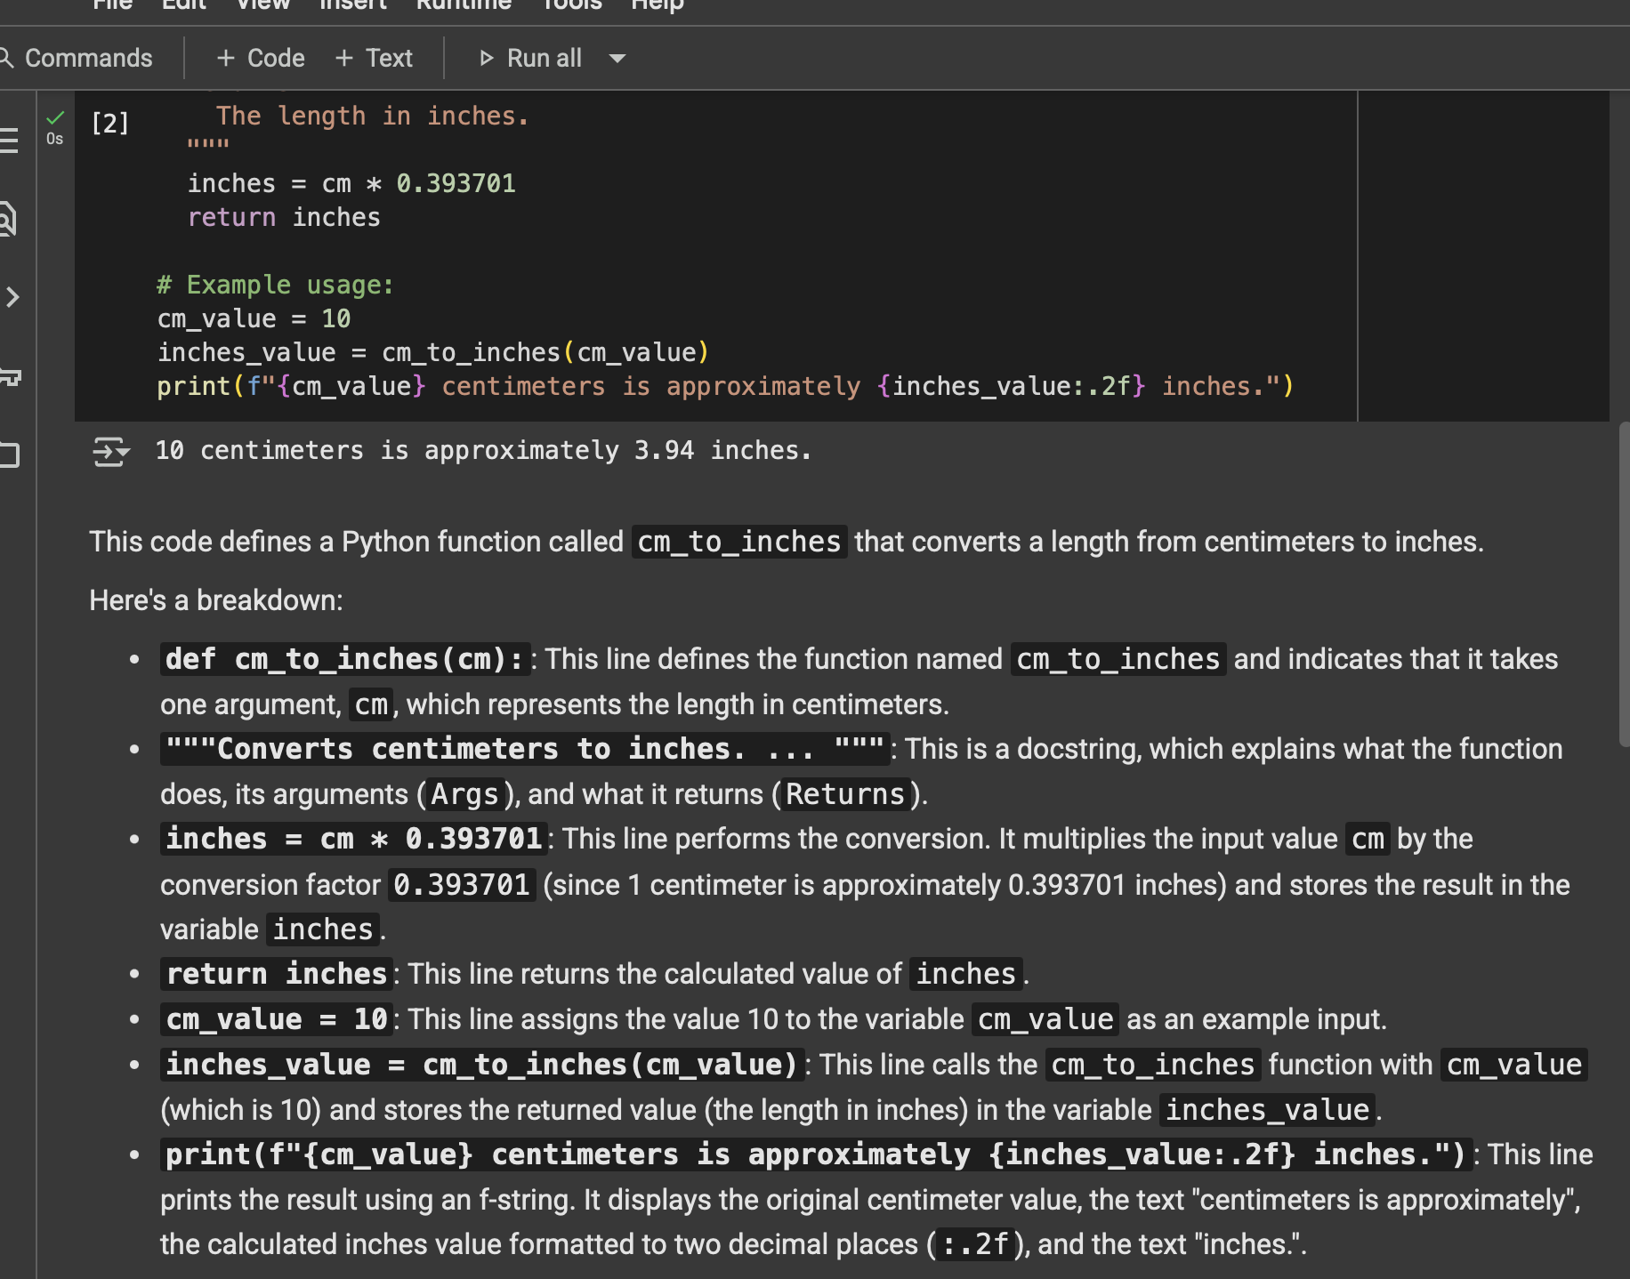

TASK 3

Few-shot: Provide 2–3 examples to generate a function that formats full names as

“Last, First

Explanation of code

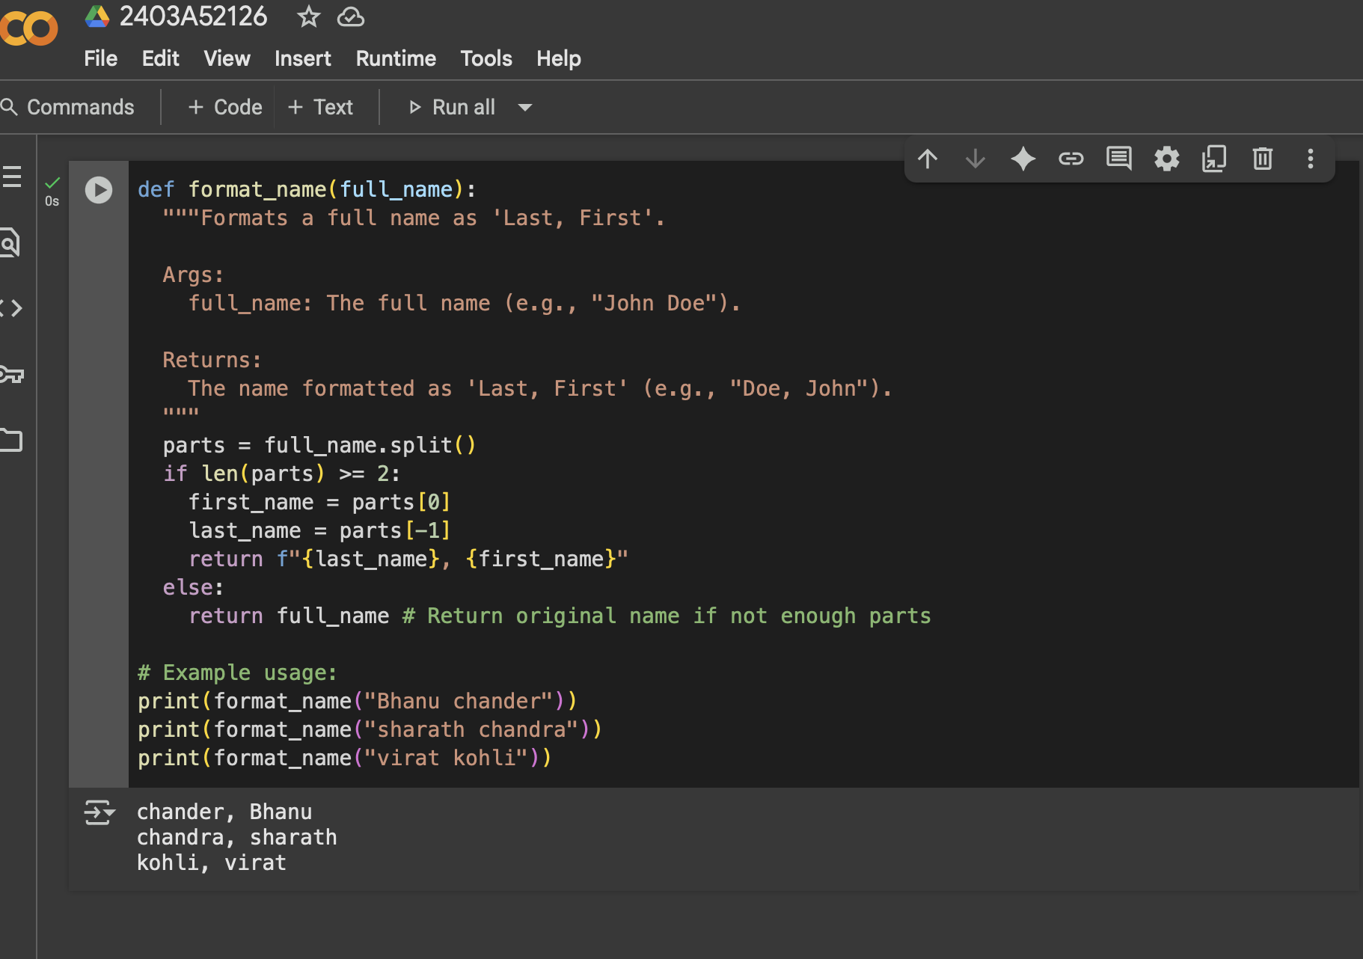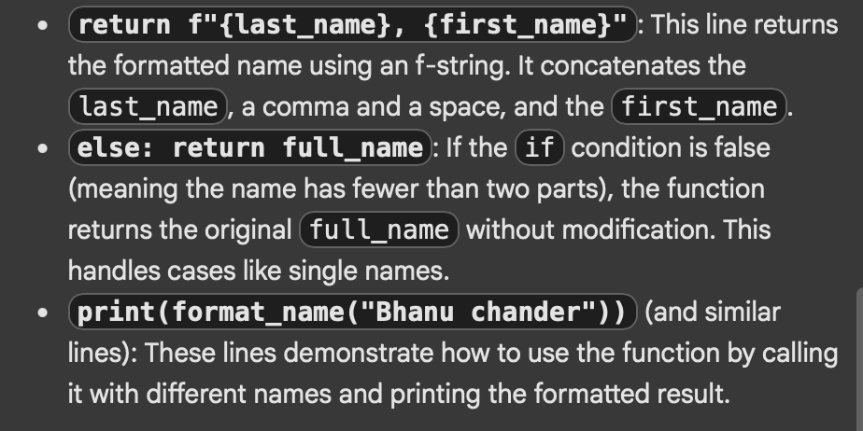

Code and output

Explanation of code

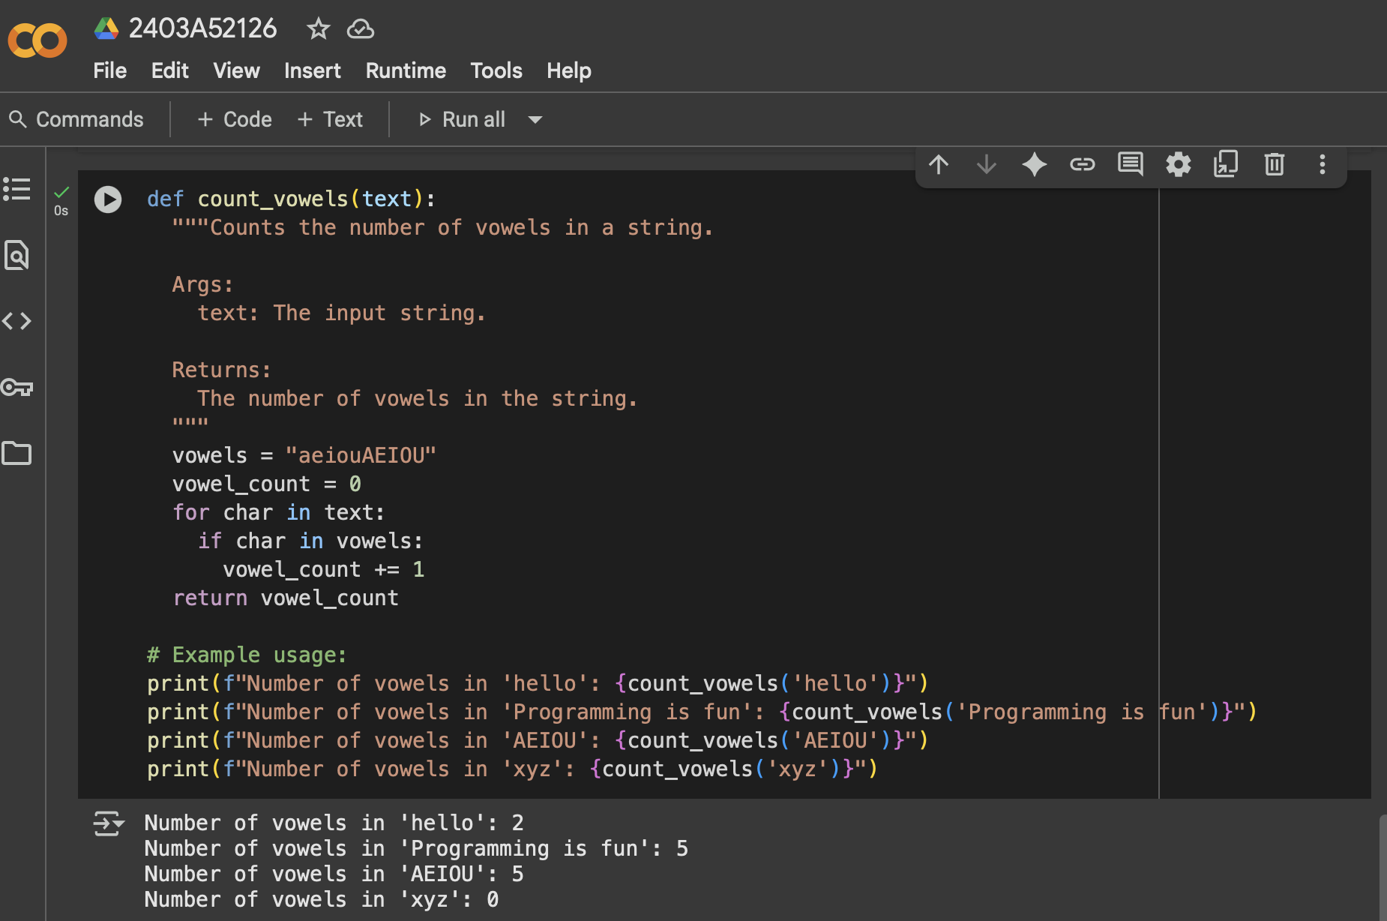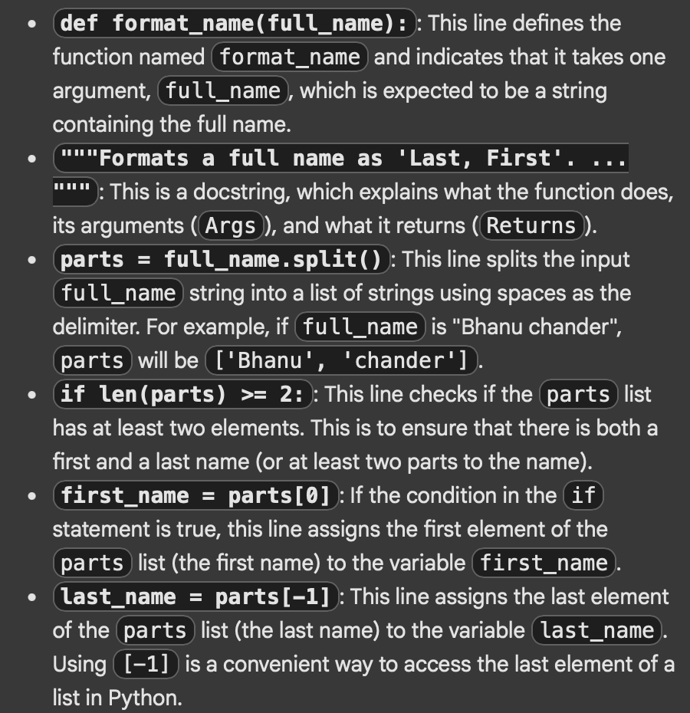

TASK 4

Compare zero-shot and few-shot prompts for writing a function that counts the

number of vowels in a string

Code and output for zero shot code

Explanation of code for zero shot code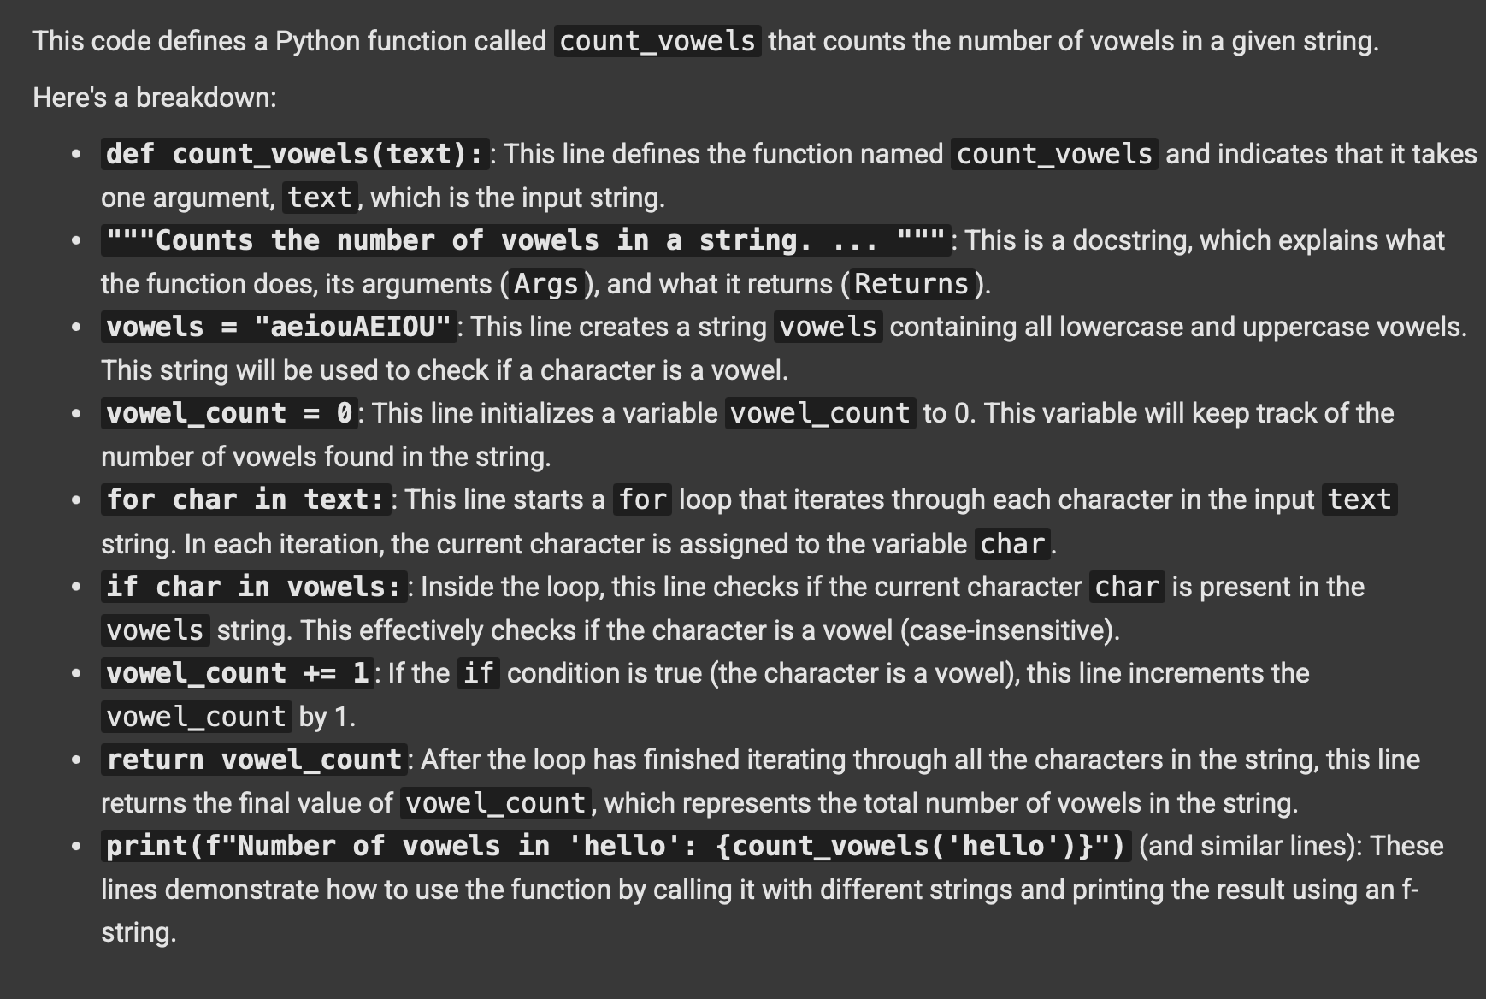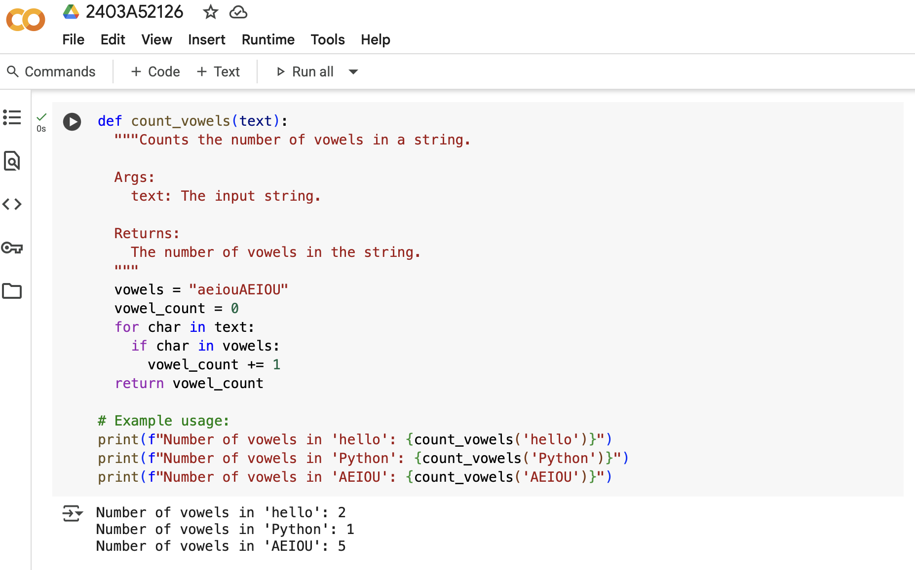

Code and output for few shot code

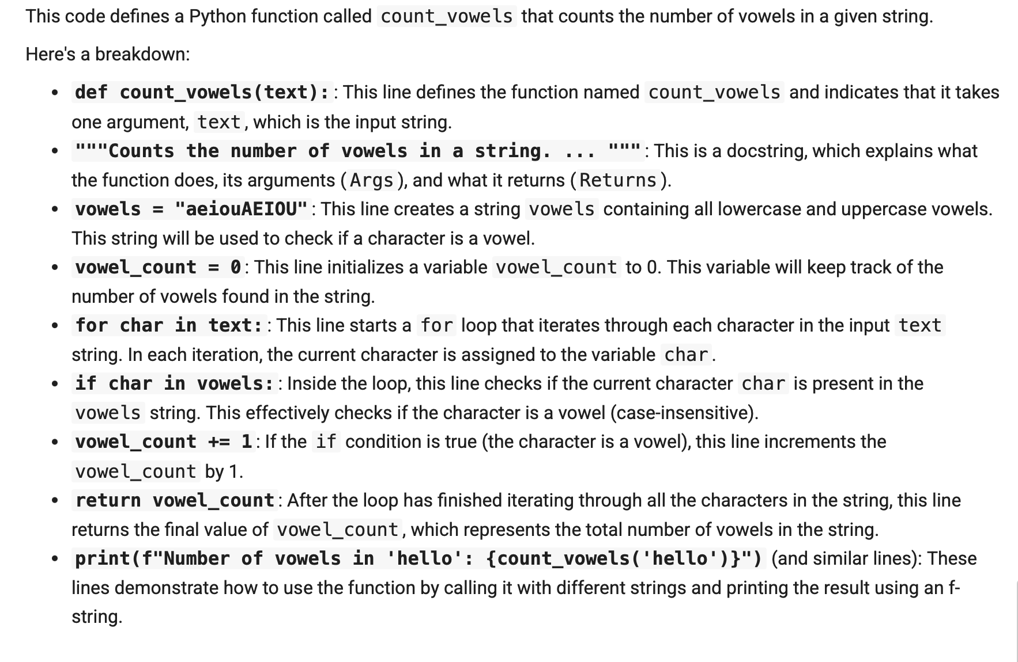

Comparison table of two explanation of codes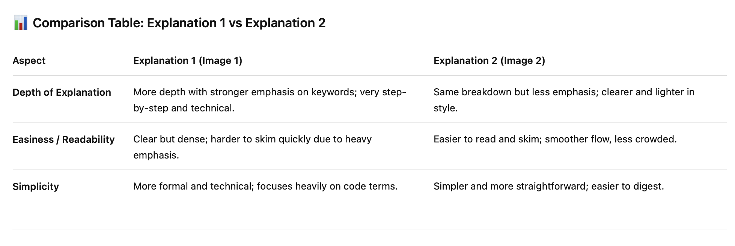

Explanation for few shot code

TASK 5

Use few-shot prompting to generate a function that reads a .txt file and returns the number of lines.

Output of the code

Code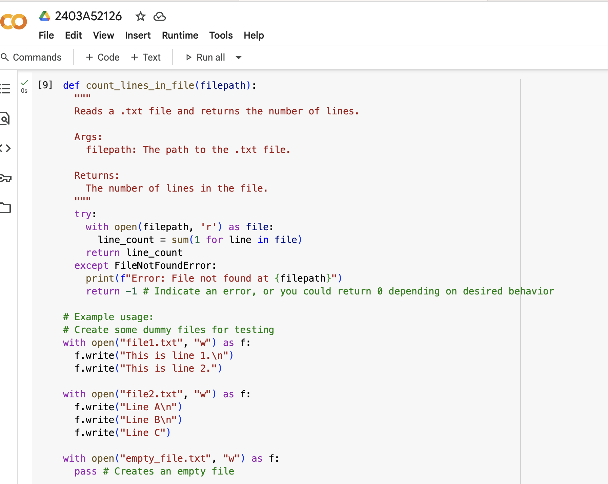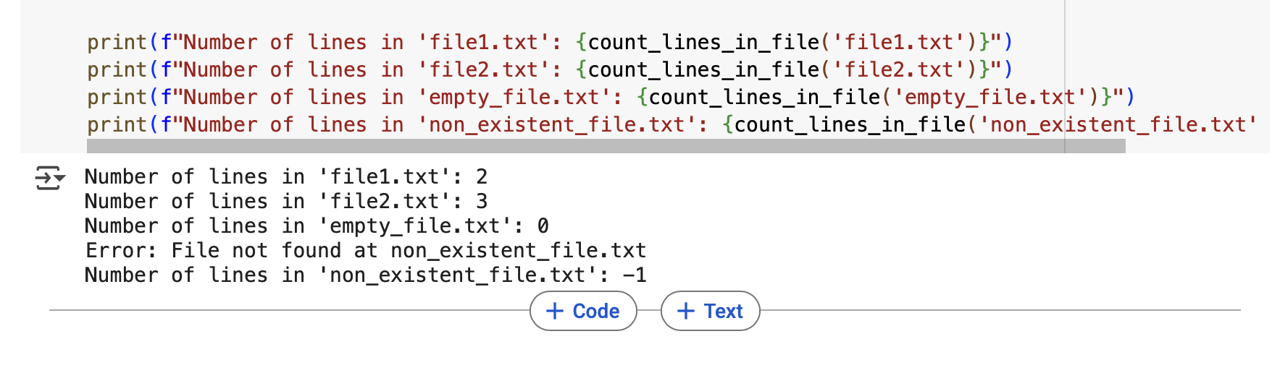

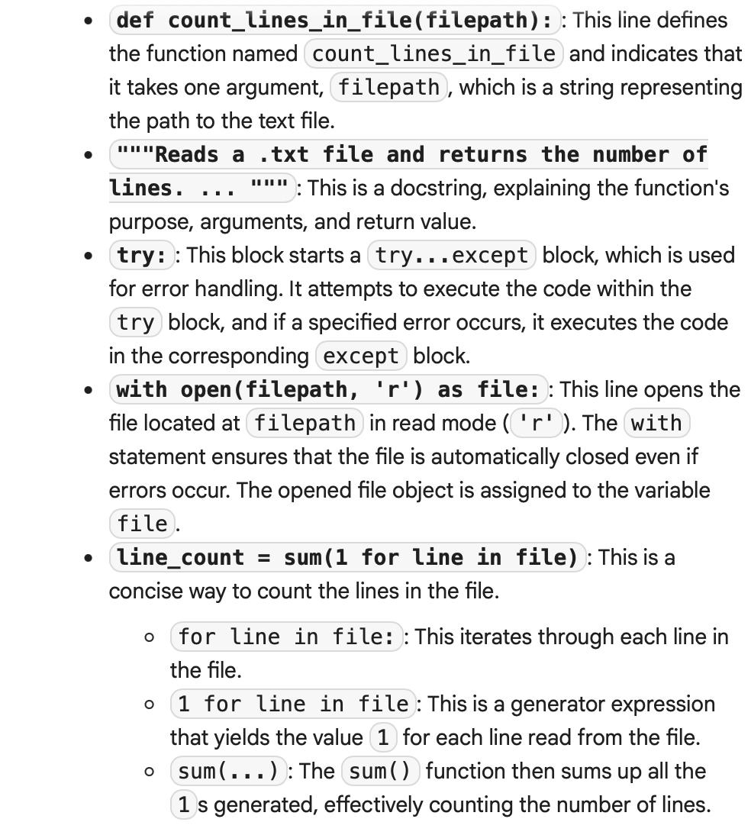

Explanation of the code

